USER MANUAL

HYBRID SOLAR INVERTER/CHARGER

Table Of Contents

Table Of Contents 1
PRODUCT OVERVIEW 1
INSTALLATION 2
Unpacking and Inspection 2
Preparation 2
Mounting the Unit 2
Battery Connection 3
AC Input/Output Connection 4
PV Connection 6
Final Assembly 8
OPERATION 9
Power ON/OFF 9
Operation and Display Panel 9
LCD Setting 10
BATTERY EQUALIZATION 16
SETTING FOR LITHIUM BATTERY 18
Fault Reference Code 23
Warning Indicator 24
SPECIFICATIONS 25
Table 1 Line Mode Specifications 25
Table 2 Inverter Mode Specifications 26
Table 3 Charge Mode Specifications 27
Table 4 General Specifications 27
TROUBLE SHOOTING 28

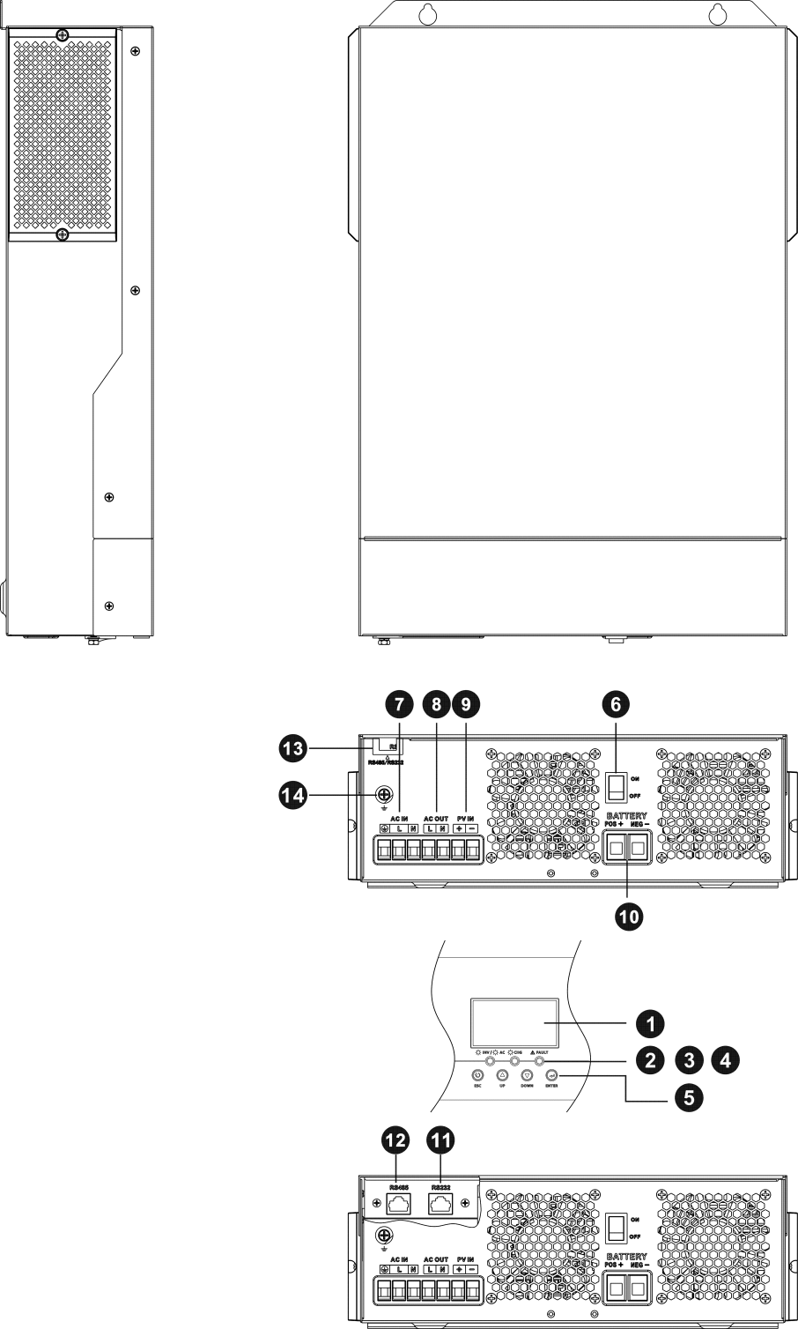
PRODUCT OVERVIEW

- LCD display
- Status indicator
- Charging indicator
- Fault indicator
- Function buttons
- Power on/off switch
- AC input
- AC output
- PV input
- Battery input
- RS232 communication port
- RS485 communication port
- Wire outlet hole
- Grounding

INSTALLATION

Unpacking and Inspection
Before installation, please inspect the unit. Be sure that nothing inside the package is damaged. You should have received the following items inside of package:
- The unit x 1
- User manual x 1

Preparation
Before connecting all wirings, please take off bottom cover by removing two screws as shown below.

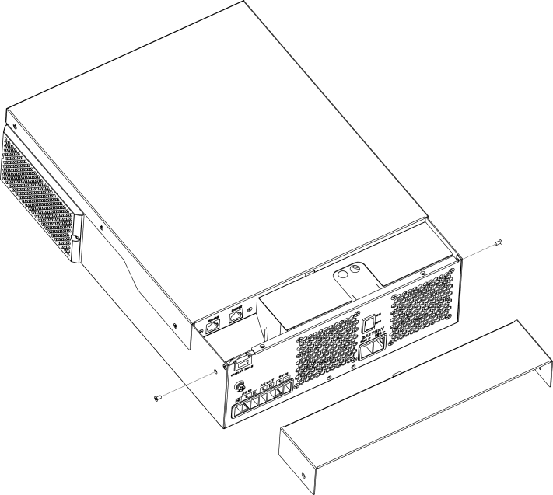

Mounting the Unit
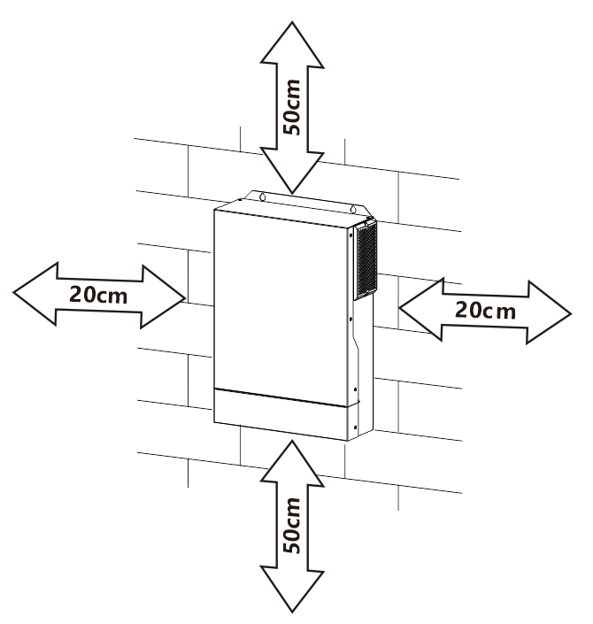
Consider the following points before selecting where to install:
- Do not mount the inverter on flammable construction materials.
- Mount on a solid surface
- Install this inverter at eye level in order to allow the LCD display to be read at all times.
- The ambient temperature should be between 0°C and 55°C to ensure optimal operation.
- The recommended installation position is to be adhered to the wall vertically.
- Be sure to keep other objects and surfaces as shown in the right diagram to guarantee sufficient heat dissipation and to have enough space for removing wires.


SUITABLE FOR MOUNTING ON CONCRETE OR OTHER NON-COMBUSTIBLE SURFACE ONLY.

Install the unit by screwing three screws. It’s recommended to use M4 or M5 screws.

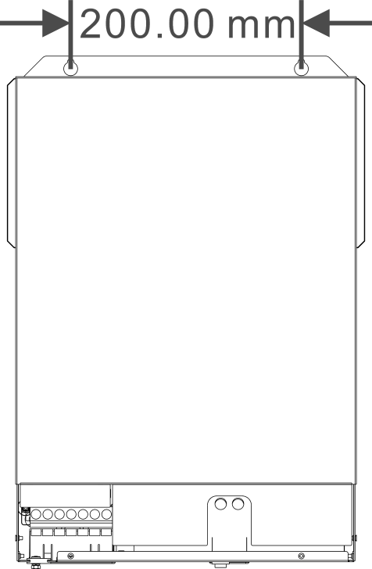

Battery Connection
CAUTION: For safety operation and regulation compliance, it’s requested to install a separate DC over-current protector or disconnect device between battery and inverter. It may not be requested to have a disconnect device in some applications, however, it’s still requested to have over-current protection installed. Please refer to typical amperage in below table as required fuse or breaker size.

Stripping Length:

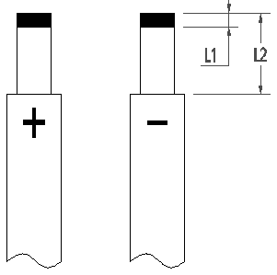
WARNING! All wiring must be performed by a qualified personnel.
WARNING! It's very important for system safety and efficient operation to use appropriate cable for battery connection. To reduce risk of injury, please use the proper recommended cable 、stripping length(L2) and tinning length(L1)
as below.

Recommended battery cable 、stripping length (L2) and tinning length(L1):

Model | Maximum Amperage | Battery capacity | Wire Size | Cable  mm2 | L1  (mm) | L 2  (mm) | Torque value
All Models | 137A | 100AH | 2AWG | 38 | 3 | 18 | 2~ 3 Nm

Please follow below steps to implement battery connection:
- Remove insulation sleeve 18 mm for positive and negative cables based on recommended stripping length.
- Connect all battery packs as units requires. It’s suggested to use recommended battery capacity.
- Insert battery cable flatly into battery connector of inverter and make sure the bolts are tightened with torque of 2-3 Nm. Make sure polarity at both the battery and the inverter/charge is correctly connected and battery cables are tightly screwed to the battery connector.

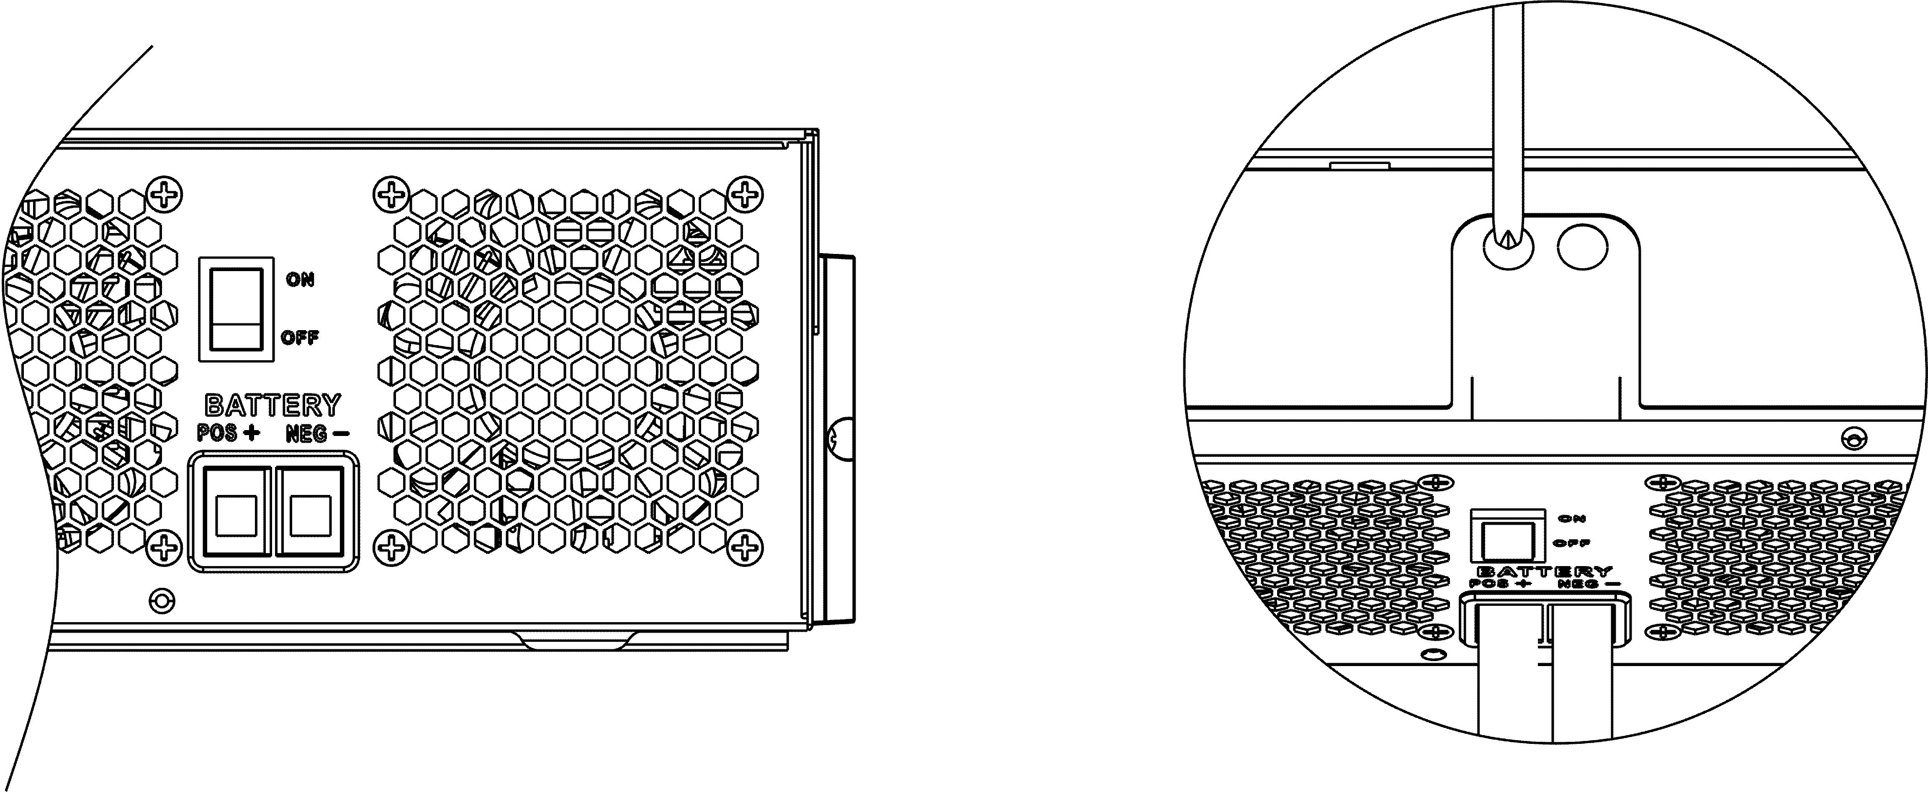
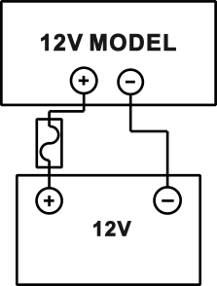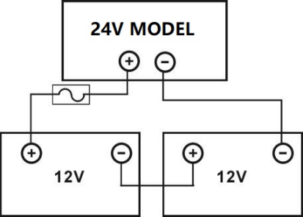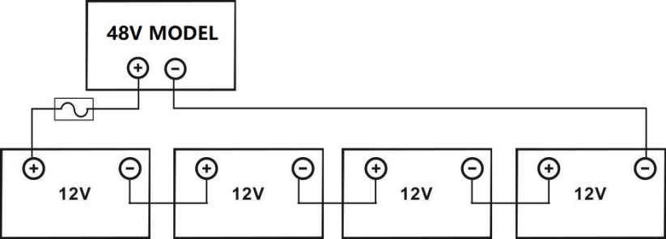

 | WARNING: Shock Hazard  Installation must be performed with care due to high battery voltage in series.

CAUTION!! Do not place anything between the flat part of the inverter terminal Otherwise, overheating may occur.
CAUTION!! Do not apply anti-oxidant substance on the terminals before terminals are connected tightly.
CAUTION!! Before making the final DC connection or closing DC breaker/disconnector, be sure positive (+) must be connected to positive (+) and negative (-) must be connected to negative
(-).

AC Input/Output Connection
CAUTION!! Before connecting to AC input power source, please install a separate AC breaker between inverter and AC input power source. This will ensure the inverter can be securely disconnected during maintenance and fully protected from over current of AC input. The recommended spec of AC breaker is 50A. CAUTION!! There are two terminal blocks with “IN” and “OUT” markings. Please do NOT mis-connect input and output connectors.

WARNING! All wiring must be performed by a qualified personnel.
WARNING! It’s very important for system safety and efficient operation to use appropriate cable for AC input connection. To reduce risk of injury, please use the proper recommended cable size as below.

Suggested cable requirement for AC wires

Model | Gauge | Torque Value
1.5KVA | 12AWG | 1.4~ 1.6Nm
3.5KVA | 10AWG | 1.4~ 1.6Nm
5.5KVA/6.2KVA | 8 AWG | 1.4~ 1.6Nm

Please follow below steps to implement AC input/output connection:
- Before making AC input/output connection, be sure to open DC protector or disconnector first.
- Remove insulation sleeve 10mm for six conductors. And shorten phase L and neutral conductor N 3 mm.
- Insert AC input wires according to polarities indicated on terminal block and tighten the terminal screws. Be sure to connect PE protective conductor (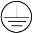) first.
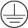→Ground (yellow-green) L→LINE (brown or black) N→Neutral (blue)
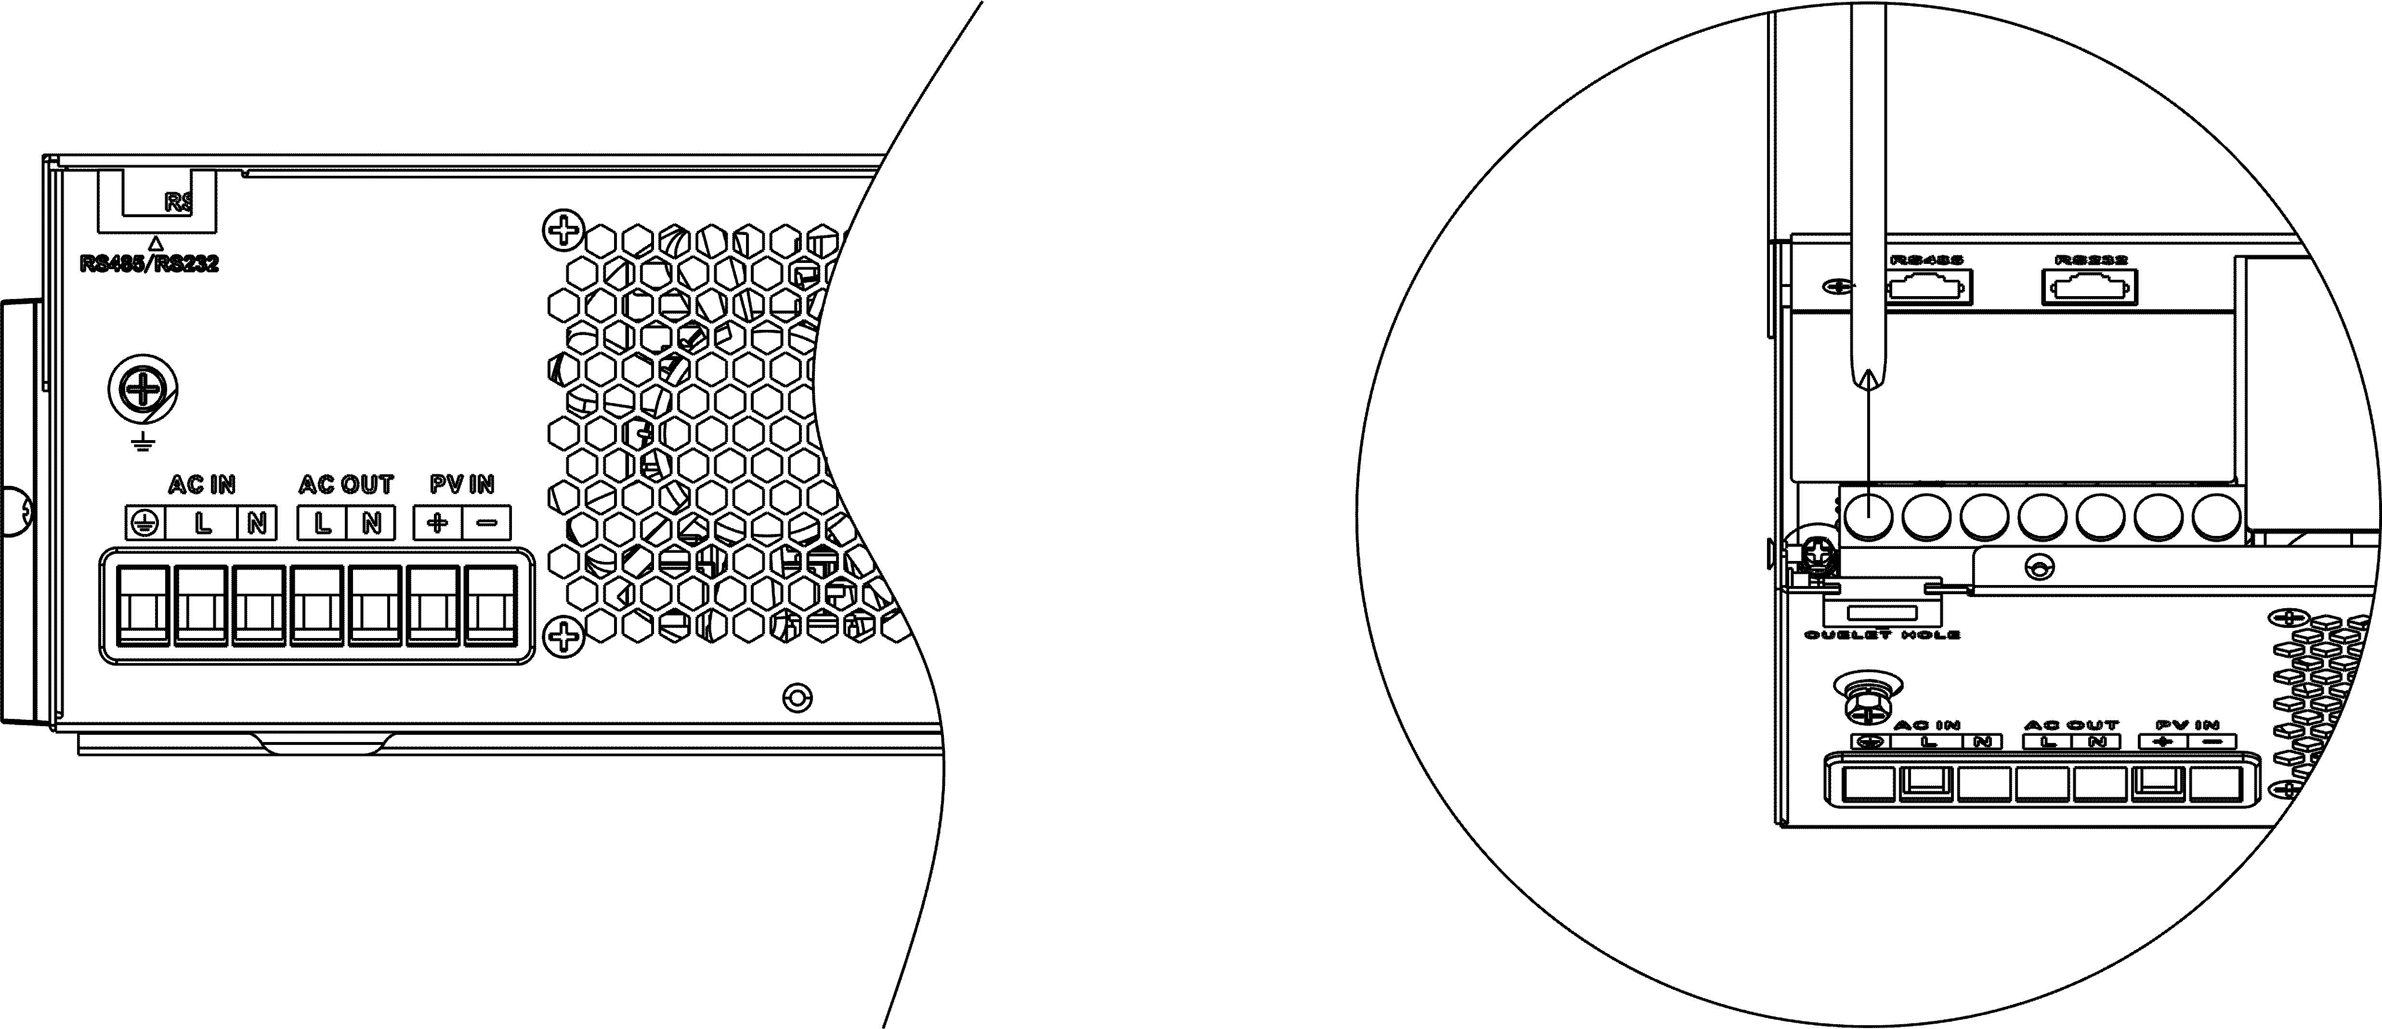
WARNING:
Be sure that AC power source is disconnected before attempting to hardwire it to the unit.

- Then, insert AC output wires according to polarities indicated on terminal block and tighten terminal screws. Be sure to connect PE protective conductor (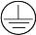) first.

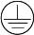→Ground (yellow-green) L→LINE (brown or black)

N→Neutral (blue)
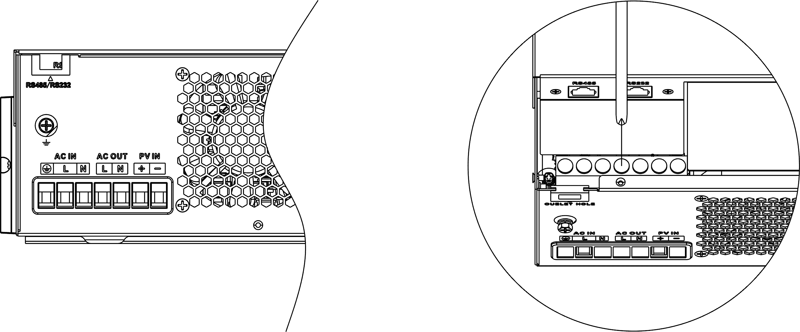
- Make sure the wires are securely connected.
CAUTION: Important
Be sure to connect AC wires with correct polarity. If L and N wires are connected reversely, it may cause utility short-circuited when these inverters are worked in parallel operation.

CAUTION: Appliances such as air conditioner are required at least 2~3 minutes to restart because it’s required to have enough time to balance refrigerant gas inside of circuits. If a power shortage occurs and recovers in a short time, it will cause damage to your connected appliances. To prevent this kind of damage, please check manufacturer of air conditioner if it’s equipped with time-delay function before installation. Otherwise, this inverter/charger will trig overload fault and cut off output to protect your appliance but sometimes it still causes internal damage to the air conditioner.

PV Connection
CAUTION: Before connecting to PV modules, please install separately a DC circuit breaker between inverter and PV modules.

WARNING! All wiring must be performed by a qualified personnel.
WARNING! It'’ very important for system safety and efficient operation to use appropriate cable for PV module connection. To reduce risk of injury, please use the proper recommended cable size as below.

Model | Typical Amperage | Cable Size | Torque
1.5KVA（PVmax=160V） | 30A | 10 AWG | 1.4~1.6 Nm
3.5KVA（PVmax=160V） | 40A | 8 AWG | 1.4~1.6 Nm
3.5KVA | 15A | 12 AWG | 1.4~1.6 Nm
5.5KVA | 18A | 12 AWG | 1.4~1.6 Nm
6.2KVA | 27A | 12 AWG | 1.4~1.6 Nm

PV Module Selection:
When selecting proper PV modules, please be sure to consider below parameters:
- Open circuit Voltage (Voc) of PV modules not exceeds max. PV array open circuit voltage of inverter.
- Open circuit Voltage (Voc) of PV modules should be higher than min. battery voltage.
Solar Charging Mode
INVERTER MODEL | 3.5KVA | 5.5KVA | 6.2KVA | 1.5K~3.5KVA  (PVmax=160V)
Max. PV Array Open Circuit Voltage | 500DC |  |  | 160VDC
PV Array MPPT Voltage Range | 60VDC~500VDC |  |  | 30-160V
Max. PV INPUT CURRENT | 15A | 18A | 27A | 30A(1.5K) | 50A(3.5K)

Take the 450Wp and 550Wp PV module as an example. After considering above two parameters, the recommended module configurations are listed in the table below.

Solar Panel Spec. (reference)  - 450Wp  - Vmp: 34.67Vdc  - Imp: 13.82A  - Voc: 41.25Vdc  - Isc: 12.98A | SOLAR INPUT | Q'ty of panels | Total input power | Inverter Model
 | 3 pcs in serial | 3 pcs | 1,350 W | 3.5KVA/5.5KVA/6.2KVA
 | 4 pcs in serial | 4 pcs | 1,800 W | 3.5KVA/5.5KVA/6.2KVA
 | 5 pcs in serial | 5 pcs | 2,250 W | 3.5KVA/5.5KVA/6.2KVA
 | 6 pcs in serial | 6 pcs | 2,700 W | 3.5KVA/5.5KVA/6.2KVA
 | 7 pcs in serial | 7 pcs | 3,150 W | 3.5KVA/5.5KVA/6.2KVA
 | 8 pcs in serial | 8 pcs | 3,600 W | 3.5KVA/5.5KVA/6.2KVA
 | 9 pcs in serial | 9 pcs | 4,050 W | 3.5KVA/5.5KVA/6.2KVA
 | 10 pcs in serial | 10 pcs | 4,500 W | 5.5KVA/6.2KVA
 | 11 pcs in serial | 11 pcs | 4,950 W | 5.5KVA/6.2KVA
 | 12 pcs in serial | 12 pcs | 5,400 W | 5.5KVA/6.2KVA
 | 6 pieces in serial and 2 sets in parallel | 12 pcs | 5,400 W | 6.2KVA
 | 8 pieces in serial and 2 sets in parallel | 14 pcs | 6,300 W | 6.2KVA
 | 1 pcs in serial | 1 pcs | 450W | 3.5KVA(PVmax=160V)
 | 2 pcs in serial | 2 pcs | 900W | 3.5KVA(PVmax=160V)
 | 3 pcs in serial | 3 pcs | 1,350 W | 3.5KVA(PVmax=160V)
Solar Panel Spec. (reference)  - 550Wp  - Vmp: 42.48Vdc  - Imp: 12.95A  - Voc: 50.32Vdc  - Isc: 13.70A | SOLAR INPUT | Q'ty of panels | Total input power | Inverter Model
 | 3 pcs in serial | 3 pcs | 1,650 W | 3.5KVA/5.5KVA/6.2KVA
 | 4 pcs in serial | 4 pcs | 2,200 W | 3.5KVA/5.5KVA/6.2KVA
 | 5 pcs in serial | 5 pcs | 2,750 W | 3.5KVA/5.5KVA/6.2KVA
 | 6 pcs in serial | 6 pcs | 3,300 W | 3.5KVA/5.5KVA/6.2KVA
 | 7 pcs in serial | 7 pcs | 3,850 W | 3.5KVA/5.5KVA/6.2KVA
 | 8 pcs in serial | 8 pcs | 4,400 W | 5.5KVA/6.2KVA
 | 9 pcs in serial | 9 pcs | 4,950 W | 5.5KVA/6.2KVA
 | 10 pcs in serial | 10 pcs | 5,500 W | 5.5KVA/6.2KVA
 | 11 pcs in serial | 11 pcs | 6,050 W | 6.2KVA
 | 12 pcs in serial | 12 pcs | 6,600 W | 6.2KVA
 | 4 pieces in serial and 2 sets in parallel | 8 pcs | 4,400 W | 6.2KVA
 | 5 pieces in serial and 2 sets in parallel | 10 pcs | 5,500 W | 6.2KVA
 | 6 pieces in serial and 2 sets in parallel | 12 pcs | 6,600 W | 6.2KVA
 | 1 pcs in serial | 1 pcs | 550W | 1.5K/3.5KVA(PVmax=160V)
 | 2 pcs in serial | 2 pcs | 1000W | 1.5K/3.5KVA(PVmax=160V)
 | 3 pcs in serial | 3 pcs | 1,500 W | 3.5KVA(PVmax=160V)

PV Module Wire Connection:

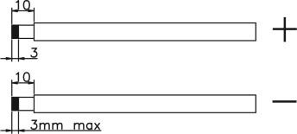
Please follow below steps to implement PV module connection:
- Remove insulation sleeve 10 mm for positive and negative conductors.
- Check correct polarity of connection cable from PV modules and PV input connectors. Then, connect positive pole (+) of connection cable to positive pole (+) of PV input connector. Connect negative pole (-) of connection cable to negative pole (-) of PV input connector.
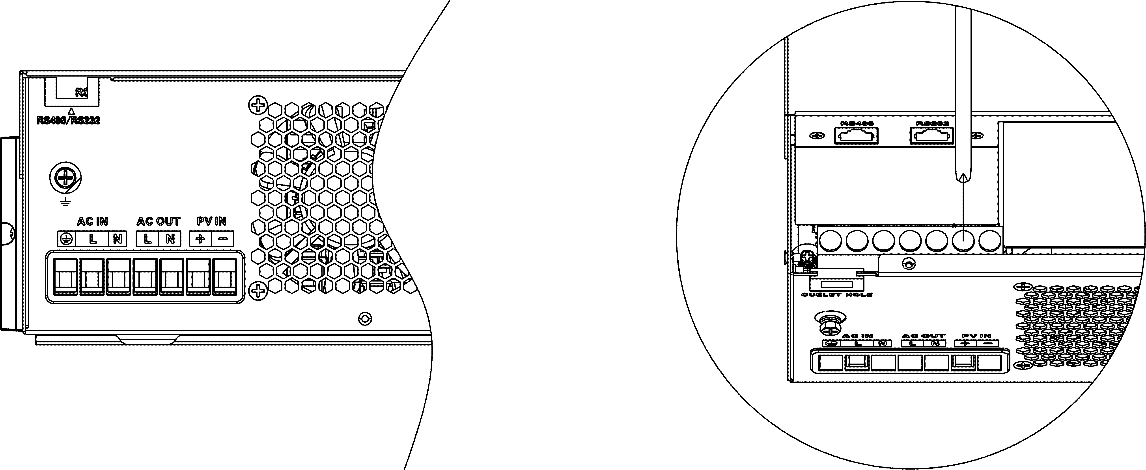
- Make sure the wires are securely connected.

Final Assembly
After connecting all wirings, please put bottom cover back by screwing two screws as shown below.

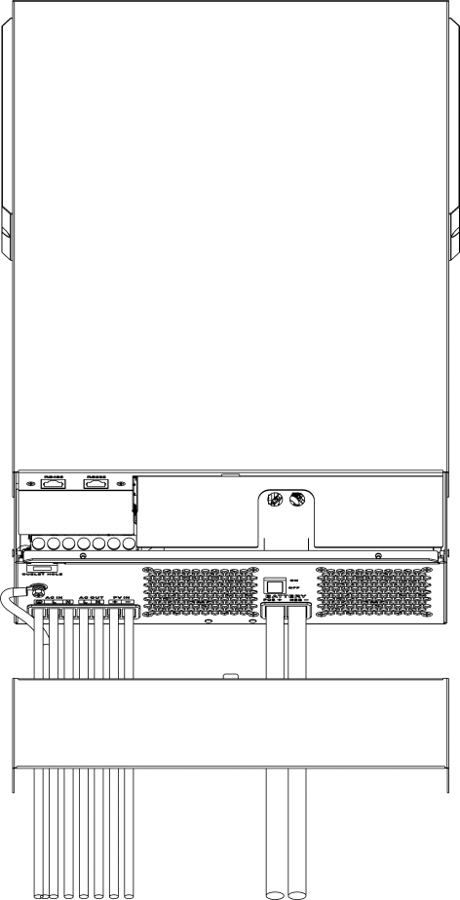

OPERATION

Power ON/OFF

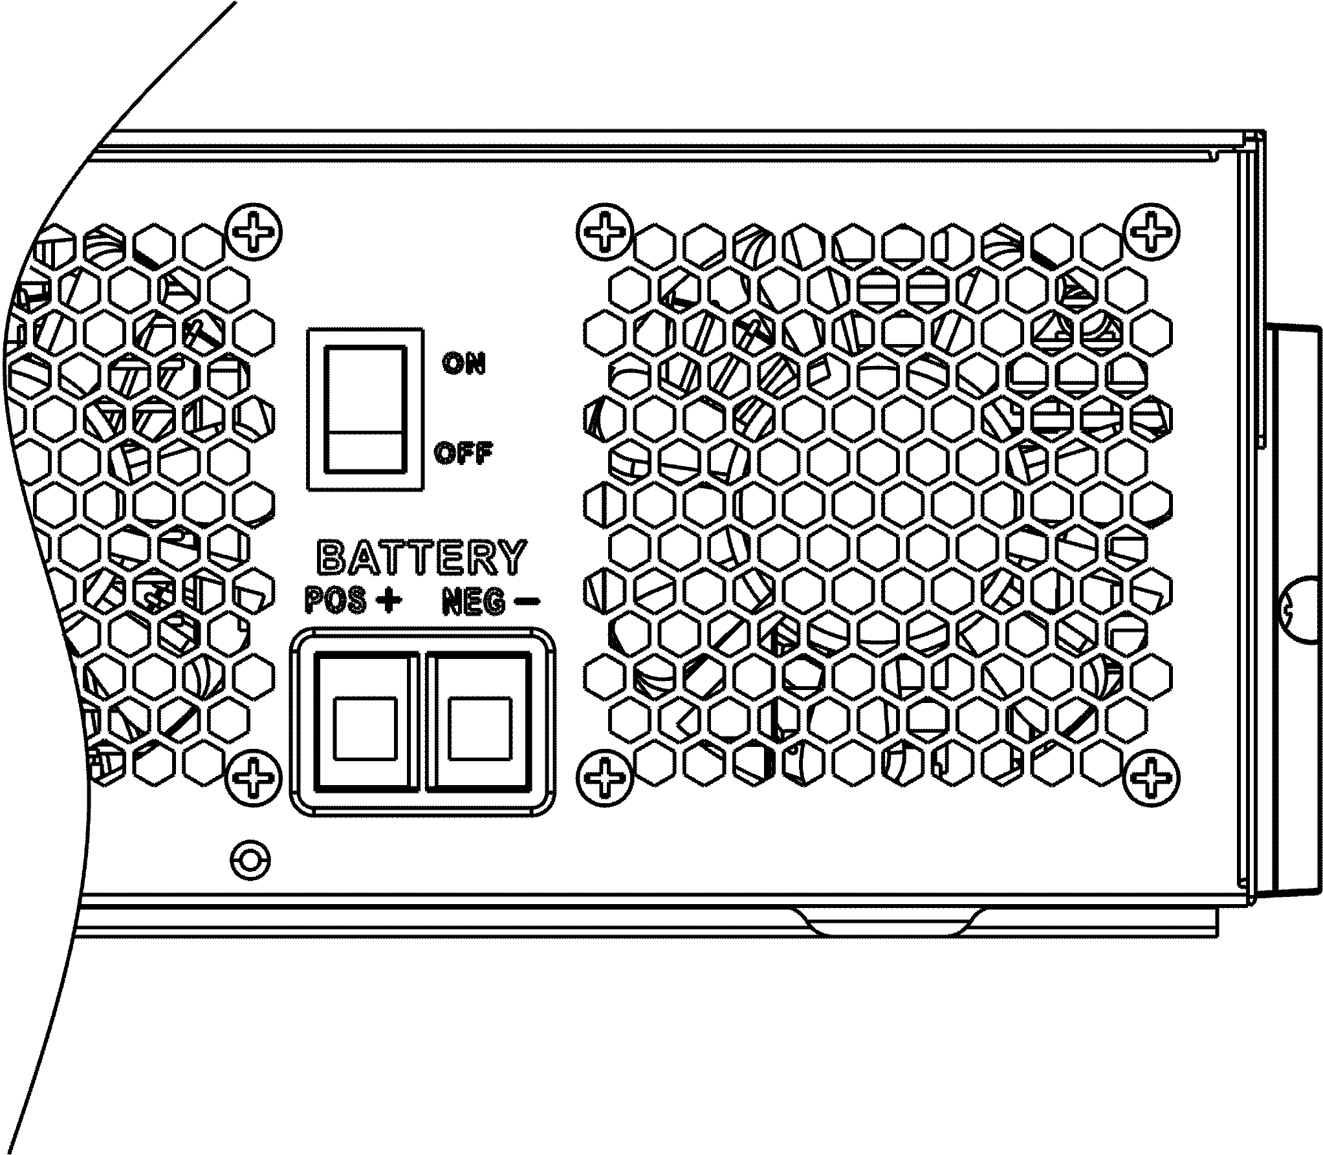

Once the unit has been properly installed and the batteries are connected well, simply press On/Off switch (located on the button of the case) to turn on the unit.

Operation and Display Panel
The operation and display panel, shown in below chart, is on the front panel of the inverter. It includes three indicators, four function keys and a LCD display, indicating the operating status and input/output power information.
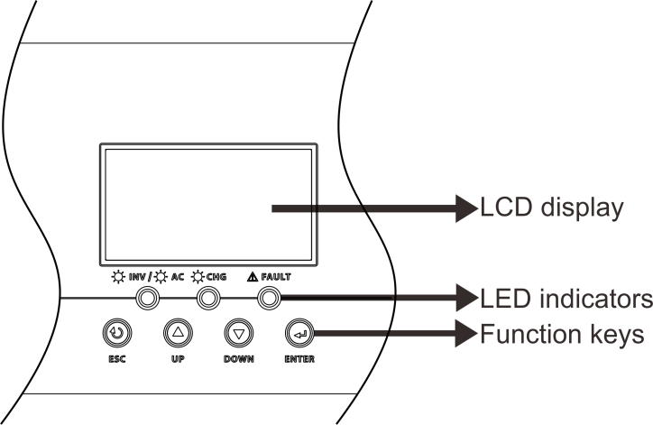

LED Indicator
LED Indicator |  |  | Messages
 | Green | Solid On | Output is powered by utility in Line mode.
 | Green | Flashing | Output is powered by battery or PV in battery mode.
 | Green | Solid On | Battery is fully charged.
 | Green | Flashing | Battery is charging.
 | Red | Solid On | Fault occurs in the inverter.
 | Red | Flashing | Warning condition occurs in the inverter.

Function Keys
Function Key | Description
ESC | To exit setting mode
UP | To go to previous selection
DOWN | To go to next selection
ENTER | To confirm the selection in setting mode or enter setting mode

LCD Setting
After pressing and holding ENTER button for 3 seconds, the unit will enter setting mode. Press “UP” or “DOWN” button to select setting programs. And then, press “ENTER” button to confirm the selection or ESC button to exit.

Setting Programs:
Program | Description | Selectable option
01 | Output source priority: To configure load power source priority | Solar first  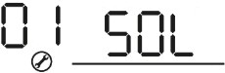 | Solar energy provides power to the loads as first priority.  If solar energy is not sufficient to power all connected loads, battery energy will supply power the loads at the same time.  Utility provides power to the loads only when any one condition happens:  - Solar energy is not available  - Battery voltage drops to either low-level warning voltage or the setting point in program 12.
01 |  | Utility first (default)  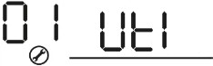 | Utility will provide power to the loads as first priority.  Solar and battery energy will provide power to the loads only when utility power is not available.
01 |  | SBU priority  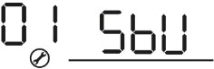 | Solar energy provides power to the loads as first priority.  If solar energy is not sufficient to power all connected loads, battery energy will supply power to the loads at the same time.  Utility provides power to the loads only when battery voltage drops to either low-level warning voltage or the setting point in program 12.
01 |  | SUB priority  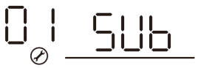 | Solar energy is charged first and then power to the loads.  If solar energy is not sufficient to  power all connected loads, Utility  energy will supply power to the  loads at the same time.  Note：SUB priority is just for PVmax=500Vdc model.
02 | Maximum charging current: To configure total charging current for solar and utility chargers.  (Max. charging current = utility charging current + solar charging current) | 60A (default)  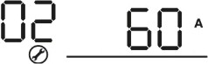 | If selected, acceptable charging current range will be from Max. AC charging current to Max. charging current of SPEC，but it shouldn’t be less than the AC charging current （program 11）
03 | AC input voltage range | Appliances (default)  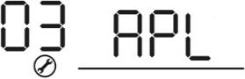 | If selected, acceptable AC input voltage range will be within  90-280VAC.
03 | AC input voltage range | UPS  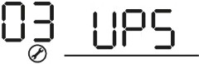 | If selected, acceptable AC input  voltage range will be within 170-280VAC.
03 | AC input voltage range | Generator  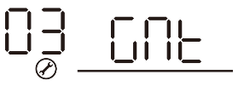 | If selected, acceptable AC input  voltage range will be within 170-280VAC and compatible with generators.  Note: Because generators are  unstable, maybe the output of inverter will be unstable too.
05 | Battery type | AGM (default)  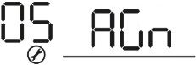 | Flooded  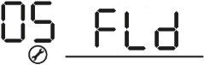
05 | Battery type | User-Defined   | If “User-Defined” is selected, battery charge voltage and low DC cut-off voltage can be set up in program 26,  27 and 29.
05 | Battery type | 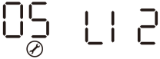 | Support PYLON US2000 Protocol  3.5 Version
05 | Battery type | 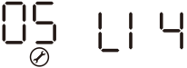 | Standard communication Protocol form inverter supplier
06 | Auto restart when overload occurs | Restart disable   | Restart enable (default)  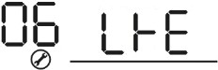
07 | Auto restart when over temperature occurs | Restart disable  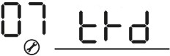 | Restart enable (default)  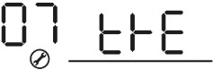
08 | Output voltage | 220V  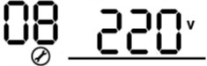 | 230V (default)  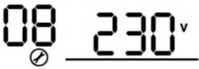
08 | Output voltage | 240V  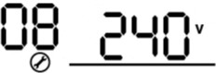
09 | Output frequency | 50Hz (default)  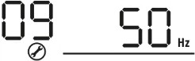 | 60Hz  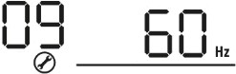
10 | Auto bypass  When selecting “auto”, if the mains power is normal, it will automatically bypass, even if the switch is off. | manual(default)  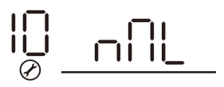 | auto  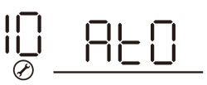
11 | Maximum utility charging current | 30A (default)  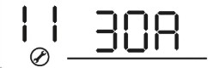  If selected, acceptable charging current range will be within 2- Max. AC charging current of SPEC.
12 | Setting voltage point back to utility source when selecting “SBU priority” or “Solar first” in program 01. | 48V models:46V (default)  Setting range is from 44.0V to 57.2V for 48v model, but the max setting value must be less than the value of program13.
12 |  | 24V models:23V (default)  Setting range is from 22.0V to 28.6V for 24v model, but The max setting value must be less than the value of program13.
12 |  | 12V models:11.5V (default)  Setting range is from 11.0V to 14.3V for 12v model, but The max setting value must be less than the value of program13.
13 | Setting voltage point back to battery mode when selecting “SBU priority” or “Solar first” in program 01. | Battery fully charged  (default)  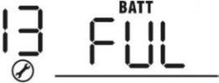 | 48V models:  Setting range is from 48V to full (the value of program26-0.4V), but the max setting value must be more than the value of program12.  24V models:  Setting range is from 24V to full (the value of program26-0.4V), but the max setting value must be more than the value of program12.  12V models:  Setting range is from 12V to full (the value of program13-0.4V), but the max setting value must be more than the value of program12.

16 | Charger source priority:  To configure charger source priority | If this inverter/charger is working in Line, Standby or Fault  mode, charger source can be programmed as below:
16 |  | Solar first  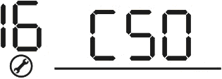 | Solar energy will charge battery as first priority.  Utility will charge battery only when  solar energy is not available.
16 |  | Solar and Utility (default) | Solar energy and utility will charge battery at the same time.
16 |  | Only Solar  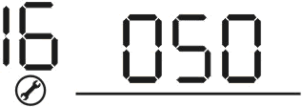 | Solar energy will be the only charger source no matter utility is available  or not.
16 |  | If this inverter/charger is working in Battery mode, only solar energy can charge battery. Solar  energy will charge battery if it's available and sufficient.
18 | Buzzer mode | Mode1   | Buzzer mute
18 | Buzzer mode | Mode2   | The buzzer sounds when the input source changes or there is a specific warning or fault
18 | Buzzer mode | Mode3   | The buzzer sounds when there is a specific warning or fault
18 | Buzzer mode | Mode4(default)   | The buzzer sounds when there is a fault
19 | Auto return to default display screen | Return to default display  screen (default) | If selected, no matter how users switch display screen, it will automatically return to default display screen (Input voltage  /output voltage) after no button is  pressed for 1 minute.
19 | Auto return to default display screen | Stay at latest screen   | If selected, the display screen will stay at latest screen user finally switches.
20 | Backlight control | Backlight on (default)  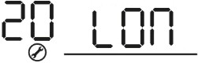 | Backlight off  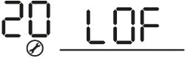
23 | Overload bypass:  When enabled, the unit will transfer to line mode if overload occurs in battery mode. | Bypass disable  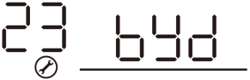 | Bypass enable(default)  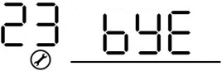
25 | Modbus ID Setting | Modbus ID Setting Range ：001(default)~247  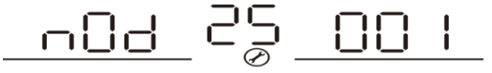
26 | Bulk charging voltage (C.V voltage) | If self-defined is selected in program 5, this program can be set  up. But the setting value must be more than or equal the value of program27. Increment of each click is 0.1V.  12V models: Default 14.1V, setting range is from 12.0V to 15.5V,  24V models: Default 28.2V, setting range is from 24.0V to 30.0V ,  48V models: Default 56.4V, setting range is from 48.0V to 62.0V.
27 | Floating charging voltage | If self-defined is selected in program 5, this program can be set  up.  12V models default setting: 13.5V  Setting range is from 12.0V to the value of program 26  24V models default setting: 27.0V  Setting range is from 24.0V to the value of program 26  48V models default setting: 54.0V  Setting range is from 48.0V to the value of program 26
29 | Low DC cut-off voltage | If self-defined is selected in program 5, this program can be set up.  The setting value must be less than the value of program12. Increment of each click is 0.1V.Low DC cut-off voltage will be fixed to setting value no matter what percentage of load is connected.  12V models default setting: 10.5v  Setting range is from 10.0V to 13.5V  24V models default setting: 21.0v  Setting range is from 20.0V to 27.0V  48V models default setting: 42.0V  Setting range is from 40.0V to 54.0V
32 | Bulk charging time (C.V stage) | Automatically (Default):  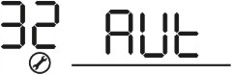 |  | If selected, inverter will judge this charging time automatically.
32 | Bulk charging time (C.V stage) | 5 min  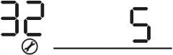 |  | The setting range is from 5 min to 900 min. Increment of each click is 5 min.
32 | Bulk charging time (C.V stage) | 900 min  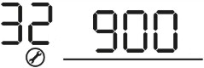
32 | Bulk charging time (C.V stage) | If “USE” is selected in program 05, this program can be set up.
33 | Battery equalization | Battery equalization  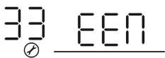 |  | Battery equalization disable (default)  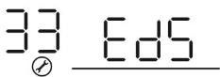
33 | Battery equalization | If “Flooded” or “User-Defined” is selected in program 05, this program can be set up.

34 | Battery equalization voltage | 12V models default setting is 14.6V. Setting range is from floating voltage ~ 15.5V. Increment of each click is 0.1V.  24V models default setting is 29.2V. Setting range is from floating voltage ~ 31V. Increment of each click is 0.1V.  48V models default setting is 58.4V. Setting range is from floating voltage ~ 64V. Increment of each click is 0.1V.
35 | Battery equalized time | 60min (default)  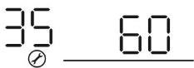 | Setting range is from 0 min to 900min.
36 | Battery equalized timeout | 120min (default)  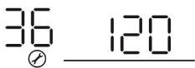 | Setting range is from 0min to  900 min.
37 | Equalization interval | 30days (default)  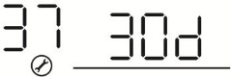 | Setting range is from 1 to 90 days.
39 | Equalization activated immediately | Enable  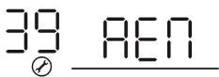 | Disable (default)  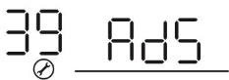
39 | Equalization activated immediately | If equalization function is enabled in program 33, this program can be set up. If “Enable” is selected in this program, it’s to activate battery equalization immediately and LCD main page will shows “ ”. If “Disable” is selected, it will cancel equalization function until next activated equalization time arrives based on program 37 setting. At this time, “” will  not be shown in LCD main page..
41 | Automatic activation for lithium battery |  |  | Disable automatic activation  (default)
41 | Automatic activation for lithium battery |  |  | When Program05 is selected “LIx” as lithium battery and when the battery is not detected, the unit will activate automatically the lithium battery at a time. If you want to activate automatically the lithium battery，you must restart the unit.
42 | Manual activation for lithium battery |  |  | Default: disable activation
42 | Manual activation for lithium battery |  |  | When Program05 is selected “LIx” as lithium battery, when the battery is not detected, If you want to activate the lithium battery at a time, you could selected it.
43 | Setting SOC point back to utility source when selecting “SBU priority” or “Solar first” in program 01 | 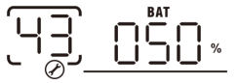 |  | Default 50%, 20%~50% Settable
44 | Setting SOC point back to battery mode when selecting “SBU priority” or “Solar first “in program 01 | 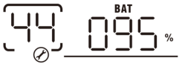 |  | Default 95%, 60%~100% Settable
45 | Low DC cut-off SOC | 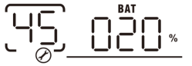 |  | Default 20%, 3%~30% Settable
46 | Maximum discharge current protection |  |  | Default OFF  Disable current discharge current protection function
46 | Maximum discharge current protection |  |  | When the discharge current exceeds setting value, the battery will stop discharging. The setting range is from 20A to 500A.

BATTERY EQUALIZATION
Equalization function is added into charge controller. It reverses the buildup of negative chemical effects like stratification, a condition where acid concentration is greater at the bottom of the battery than at the top. Equalization also helps to remove sulfate crystals that might have built up on the plates. If left unchecked, this condition, called sulfation, will reduce the overall capacity of the battery. Therefore, it’s recommended to equalize battery periodically.

How to Apply Equalization Function
You must enable battery equalization function in monitoring LCD setting program 33 first. Then, you may apply this function in device by either one of following methods:
- Setting equalization interval in program 37.
- Active equalization immediately in program 39.

When to Equalize
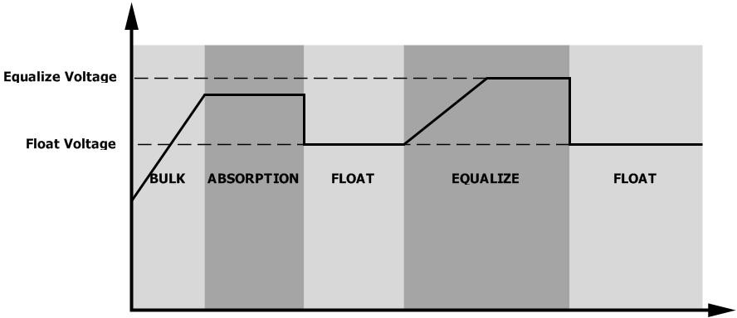
In float stage, when the setting equalization interval (battery equalization cycle) is arrived, or equalization is active immediately, the controller will start to enter Equalize stage.

Equalize charging time and timeout
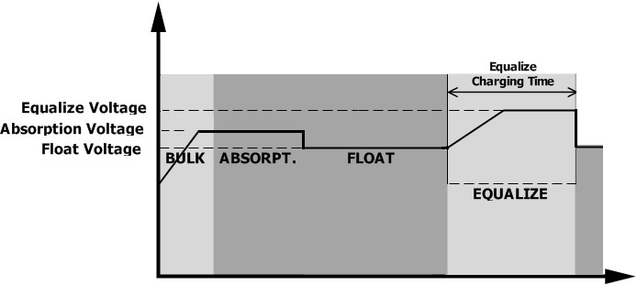
In Equalize stage, the controller will supply power to charge battery as much as possible until battery voltage raises to battery equalization voltage. Then, constant-voltage regulation is applied to maintain battery voltage at the battery equalization voltage. The battery will remain in the Equalize stage until setting battery equalized time is arrived.

However, in Equalize stage, when battery equalized time is expired and battery voltage doesn’t rise to battery equalization voltage point, the charge controller will extend the battery equalized time until battery voltage achieves battery equalization voltage. If battery voltage is still lower than battery equalization voltage when battery equalized timeout setting is over, the charge controller will stop equalization and return to float stage.
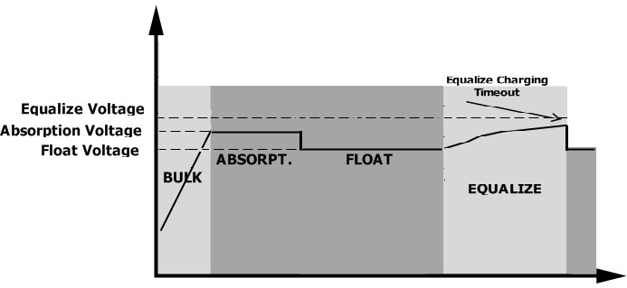

SETTING FOR LITHIUM BATTERY

Lithium Battery Connection
If choosing lithium battery for the inverter, you are allowed to use the lithium battery only which we have configured. There’re two connectors on the lithium battery, RS485 port of BMS and power cable.
Please follow below steps to implement lithium battery connection:
1). Assemble battery terminal based on recommended battery cable and terminal size (same as Lead acid, see section Lead-acid Battery connection for details).
2). Connect the end of RS485 port of battery to BMS(RS485) communication port of inverter.
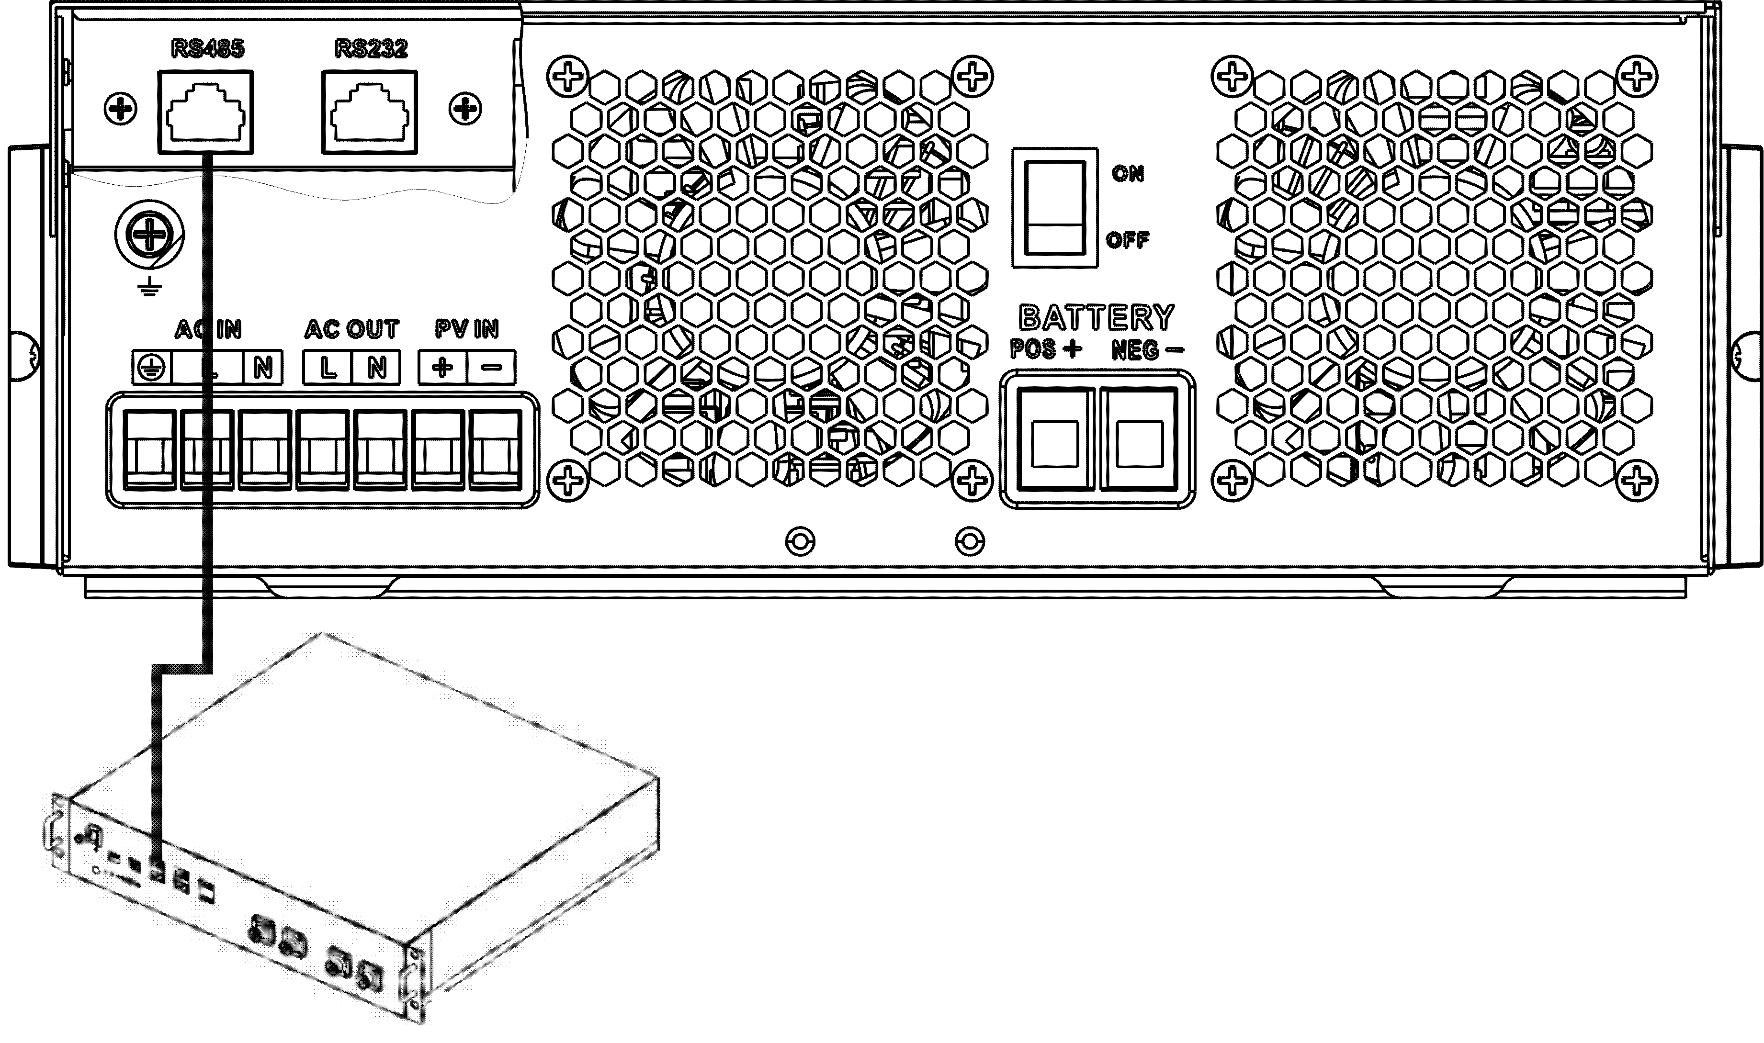
Fig 1

Lithium battery communication and setting
if choosing lithium battery, make sure to connect the BMS communication cable between the battery and the inverter. This communication cable delivers information and signal between lithium battery and the inverter. This information is listed below:
● Re-configure charging voltage, charging current and battery discharge cut-off voltage according to the lithium battery parameters.
● Have the inverter start or stop charging according to the status of lithium battery.

Connect the end of RS485 of battery to RS485 communication port of inverter
Make sure the lithium battery RS485 port connects to the inverter is Pin to Pin, the communication cable is inside of package and the inverter RS485 port pin assignment shown as below:

Pin number | RS485 Port
PIN1 | RS485-B
PIN2 | RS485-A
PIN7 | RS485-A
PIN8 | RS485-B

LCD setting
After connecting, you need to finish and confirm some settings as follow:
- Select program 05 as lithium battery type.
- Confirm program41/42/43/44/45 setting value.
Note: Program 43/44/45 are only available with successful communication, they will replace the Program 12/13/29 function, at the same time, program 12/13/29 become unavailable.

LCD Display
If communication between the inverter and battery is successful, there is some information showing on the LCD as follow：
Item | Description | LCD display
1 | Communication successful icon | - will be flashing  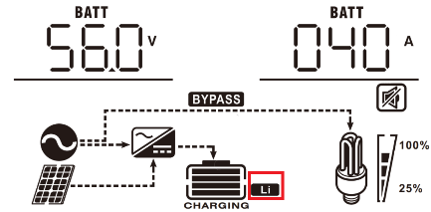
2 | Max lithium battery charging voltage | 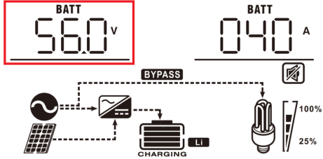  Max lithium battery charging voltage is 56.0V.
3 | Max lithium battery charging current | 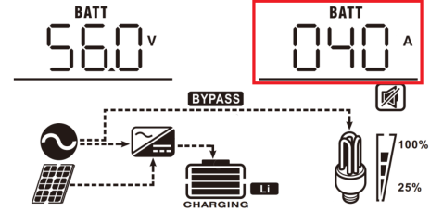  Max lithium battery charging current is 40A.
4 | Lithium battery discharging is forbidden | will flash once every 1 second
5 | Lithium battery charging is forbidden | will flash once every 2 second
6 | Lithium battery SOC(%) | 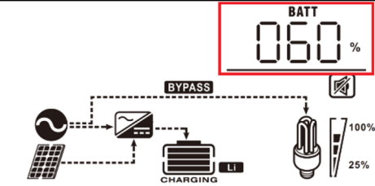  Lithium battery SOC is 63AH and 60%

Setting for PYLON US2000 lithium battery
1). PYLONTECH US2000 lithium battery setting:
Dip Switch: There are 4 Dip Switches that sets different baud rate and battery group address. If switch position is turned to the “OFF” position, it means “0”. If switch position is turned to the “ON” position, it means “1”.
Dip 1 is “ON” to represent the baud rate 9600.
Dip 2, 3 and 4 are reserved for battery group address.
Dip switch 2, 3 and 4 on master battery (first battery) are to set up or change the group address.
NOTE: “1” is upper position and “0” is bottom position.

2). Process of install
Step 1. Use the RS485 cable to connect inverter and Lithium battery as Fig 1.
Step 2. Switch on Lithium battery.
Step 3. Press more than three seconds to start Lithium battery, power output ready.
Step 4. Turn on the inverter.
Step 5. Be sure to select battery type as “Li2” in LCD program 5.
If communication between the inverter and battery is successful, the battery icon on LCD display will light

Setting for lithium battery without communication
This suggestion is used for lithium battery application and avoid lithium battery BMS protection without communication, please finish the setting as follow:
1.Before starting setting，you must get the battery BMS specification：
A. Max charging voltage
B. Max charging current
C. Discharging protection voltage

2.Set battery type as“USE”（user-defined）
05 | Battery type | AGM (default) | Flooded
05 | Battery type | User-Defined | If “User-Defined” is selected, battery charge voltage and low DC cut-off voltage can be set up in program 26,  27 and 29.

3. Set C.V voltage as Max charging voltage of BMS-0.5V.
26 | Bulk charging voltage (C.V voltage) | If self-defined is selected in program 5, this program can be set  up. But the setting value must be more than or equal the value of program27. Increment of each click is 0.1V.  12V models: Default 14.1V, setting range is from 12.0V to 15.5V,  24V models: Default 28.2V, setting range is from 24.0V to 30.0V ,  48V models: Default 56.4V, setting range is from 48.0V to 62.0V.

4. Set floating charging voltage as C.V voltage.
27 | Floating charging voltage | If self-defined is selected in program 5, this program can be set  up.  12V models default setting: 13.5V  Setting range is from 12.0V to the value of program 26  24V models default setting: 27.0V  Setting range is from 24.0V to the value of program 26  48V models default setting: 54.0V  Setting range is from 48.0V to the value of program 26

5. Set Low DC cut-off voltage ≥discharging protection voltage of BMS+2V.
29 | Low DC cut-off voltage | If self-defined is selected in program 5, this program can be set up.  The setting value must be less than the value of program12. Increment of each click is 0.1V.Low DC cut-off voltage will be fixed to setting value no matter what percentage of load is connected.  12V models default setting: 10.5v  Setting range is from 10.0V to 13.5V  24V models default setting: 21.0v  Setting range is from 20.0V to 27.0V  48V models default setting: 42.0V  Setting range is from 40.0V to 54.0V

6. Set Max charging current which must be less than the Max charging current of BMS.
02 | Maximum charging current: To configure total charging current for solar and utility chargers.  (Max. charging current = utility charging current + solar charging current) | 60A (default) | If selected, acceptable charging current range will be within 1- Max. charging current of SPEC，but it shouldn’t be less than the AC charging current （program 11）

7. Setting voltage point back to utility source when selecting “SBU priority” or “Solar first” in program 01.The setting value must be ≥Low DC cut-off voltage+1V，or else the inverter will have a warning as battery voltage low.
12 | Setting voltage point back to utility source when selecting “SBU priority” or “Solar first” in program 01. | 48V models:46V (default)  Setting range is from 44.0V to 57.2V for 48v model, but the max setting value must be less than the value of program13.
12 |  | 24V models:23V (default)  Setting range is from 22.0V to 28.6V for 24v model, but The max setting value must be less than the value of program13.
12 |  | 12V models:11.5V (default)  Setting range is from 11.0V to 14.3V for 12v model, but The max setting value must be less than the value of program13.

Remark:
1.you’d better to finish setting without turn on the inverter(just let the LCD show, no output);

2.when you finish setting, please restart the inverter.
Fault Reference Code

Fault Code | Fault Event | Icon on
01 | Over temperature of inverter module | 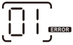
02 | Over temperature of DCDC module | 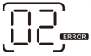
03 | Battery voltage is too high | 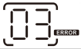
04 | Over temperature of PV module | 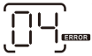
05 | Output short circuited. | 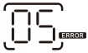
06 | Output voltage is too high. | 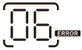
07 | Overload time out | 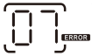
08 | Bus voltage is too high | 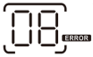
09 | Bus soft start failed | 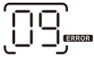
10 | PV over current | 
11 | PV over voltage | 
12 | DCDC over current | 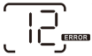
13 | Over current or surge | 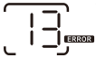
14 | Bus voltage is too low | 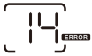
15 | Inverter failed (Self-checking) | 
18 | Op current offset is too high | 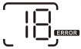
19 | Inverter current offset is too high | 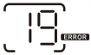
20 | DC/DC current offset is too high | 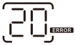
21 | PV current offset is too high | 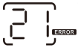
22 | Output voltage is too low | 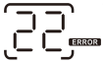
23 | Inverter negative power | 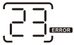

Warning Indicator

Warning Code | Warning Event | Audible Alarm | Icon flashing
02 | Temperature is too High | Beep three times every second | 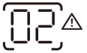
04 | Low battery | Beep once every second | 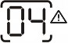
07 | Overload | Beep once every 0.5 second | 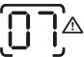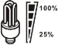
10 | Output power derating | Beep twice every 3 seconds | 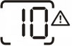
14 | Fan blocked | None | 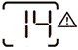
15 | PV energy is low | Beep twice every 3 seconds | 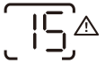
19 | Lithium Battery communication is failed | Beep once every 0.5 second | 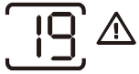
21 | Lithium Battery over current | None | 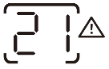
 | Battery equalization | None | 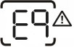
 | Battery is not connected | None | 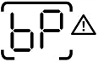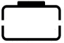

SPECIFICATIONS

Table 1 Line Mode Specifications

INVERTER MODEL | 1.5KVA | 3.5KVA | 3.5KVA | 5.5KVA | 6.2KVA
INVERTER MODEL | PVmax=160V |  | 3.5KVA | 5.5KVA | 6.2KVA
Input Voltage Waveform | Sinusoidal (utility or generator)
Nominal Input Voltage | 230Vac
Low Loss Voltage | 170Vac±7V (UPS)  90Vac±7V (Appliances)
Low Loss Return Voltage | 180Vac±7V (UPS);  100Vac±7V (Appliances)
High Loss Voltage | 280Vac±7V
High Loss Return Voltage | 270Vac±7V
Max AC Input Voltage | 300Vac
Nominal Input Frequency | 50Hz / 60Hz (Auto detection)
Low Loss Frequency | 40±1Hz
Low Loss Return Frequency | 42±1Hz
High Loss Frequency | 65±1Hz
High Loss Return Frequency | 63±1Hz
Output Short Circuit Protection | Battery mode: Electronic Circuits
Efficiency (Line Mode) | >95% ( Rated R load, battery full charged )
Transfer Time | 10ms typical (UPS); 20ms typical (Appliances)
Output power derating:  When AC input voltage drops to 95V or 170V depending on models, the output power will be derated. | Output Power  Rated Power 50%  Power  90V 170V 280V Input Voltage

Table 2 Inverter Mode Specifications

INVERTER MODEL | 1.5KVA | 3.5KVA | 3.5KVA | 5.5KVA | 6.2KVA
INVERTER MODEL | PVmax=160V |  | 3.5KVA | 5.5KVA | 6.2KVA
Rated Output Power | 1.5KVA/1.5KW | 3.5KVA/3.5KW |  | 5.5KVA/5.5KW | 6.2KVA/6.2KW
Output Voltage Waveform | Pure Sine Wave
Output Voltage Regulation | 230Vac±5%
Output Frequency | 50Hz or 60Hz
Peak Efficiency | 94%
Surge Capacity | 2* rated power for 5 seconds
Nominal DC Input Voltage | 12Vdc | 24Vdc |  | 48Vdc
Cold Start Voltage | 11.0Vdc | 23.0Vdc |  | 46.0Vdc
Low DC Warning Voltage  Just for AGM and Flooded  @ load < 20%  @ 20% ≤ load < 50%  @ load ≥ 50% | 11.0Vdc  10.7Vdc  10.1Vdc | 22.0Vdc  21.4Vdc  20.2Vdc |  | 44.0Vdc  42.8Vdc  40.4Vdc
Low DC Warning Return Voltage  Just for AGM and Flooded  @ load < 20%  @ 20% ≤ load < 50%  @ load ≥ 50% | 11.5Vdc  11.2Vdc  10.6Vdc | 23.0Vdc  22.4Vdc  21.2Vdc |  | 46.0Vdc  44.8Vdc  42.4Vdc
Low DC Cut-off Voltage  Just for AGM and Flooded  @ load < 20%  @ 20% ≤ load < 50%  @ load ≥ 50% | 10.5Vdc  10.2Vdc  9.6Vdc | 21.0Vdc  20.4Vdc  19.2Vdc |  | 42.0Vdc  40.8Vdc  38.4Vdc

Table 3 Charge Mode Specifications

Utility Charging Mode
INVERTER MODEL |  | 1.5KVA | 3.5KVA | 3.5KVA | 5.5KVA | 6.2KVA
 |  | PVmax=160V |  | 3.5KVA | 5.5KVA | 6.2KVA
Max Charging Current (PV+AC)  (@ VI/P=230Vac) |  | 120Amp |  | 100Amp | 100Amp | 120Amp
Max Charging Current  (AC)  (@ VI/P=230Vac) |  | 80Amp
Bulk Charging Voltage | Flooded  Battery | 14.6Vdc | 29.2Vdc |  | 58.4Vdc
Bulk Charging Voltage | AGM / Gel  Battery | 14.1Vdc | 28.2Vdc |  | 56.4Vdc
Floating Charging Voltage |  | 13.5Vdc | 27Vdc |  | 54Vdc
Overcharge Protection |  | 15.5 Vdc | 33Vdc |  | 63Vdc
Charging Algorithm |  | 3-Step
Charging Curve |  | Battery Voltage, per cell Charging Current, %  2.43Vdc (2.35Vdc) Voltage  2.25Vdc  100%  50%  T0 T1  T1 = 10* T0, minimum 10mins, maximum 8hrs  Current  Time  Bulk Absorption Maintenance  (Constant Current) (Constant Voltage) (Floating)
Solar Input
INVERTER MODEL |  | 1.5KVA | 3.5KVA | 3.5KVA | 5.5KVA | 6.2KVA
 |  | PVmax=160V |  | 3.5KVA | 5.5KVA | 6.2KVA
Rated Power |  | 900W | 1500W | 4000W | 5500W | 6500W
Max. PV Array Open Circuit  Voltage |  | 160Vdc |  | 500Vdc
PV Array MPPT Voltage  Range |  | 30Vdc~160Vdc |  | 60Vdc~500Vdc
Max. Input Current |  | 30A | 50A | 15A | 18A | 27A
Max. Charging Current(PV) |  | 60A |  | 100A | 100A | 120A

Table 4 General Specifications
INVERTER MODEL | 1.5KVA | 3.5KVA | 3.5KVA | 5.5KVA | 6.2KVA
INVERTER MODEL | PVmax=160V |  | 3.5KVA | 5.5KVA | 6.2KVA
Operating Temperature  Range | -10°C to 55°C
Storage temperature | -15°C~ 60°C
Humidity | 5% to 95% Relative Humidity (Non-condensing)
Dimension(D*W*H), mm | 358x295x105 |  |  | 438x295x105
Net Weight, kg | 5.8 | 6.2 |  | 8.2 | 8.7

TROUBLE SHOOTING

Problem | LCD/LED/Buzzer | Explanation / Possible cause | What to do
Unit shuts down automatically  during startup process. | LCD/LEDs and buzzer will be active for 3  seconds and then complete off. | The battery voltage is too low | - Re-charge battery.  - Replace battery.
No response after power on. | No indication. | - The battery voltage is far too low.  - Battery polarity is connected reversed. | - Check if batteries and the wiring are connected well.  - Re-charge battery.  - Replace battery.
Mains exist but the unit works in battery mode. | Input voltage is displayed as 0 on the LCD and green LED is  flashing. | Input protector is tripped | Check if AC breaker is tripped and AC wiring is connected well.
Mains exist but the unit works in battery mode. | Green LED is flashing. | Insufficient quality of AC power. (Shore or Generator) | - Check if AC wires are too thin and/or too long.  - Check if generator (if applied) is working well or if  input voltage range setting is correct. (UPS→Appliance)
Mains exist but the unit works in battery mode. | Green LED is flashing. | Set “Solar First” as the priority of output source. | Change output source priority to Utility first.
When the unit is turned on, internal  relay is switched on and off repeatedly. | LCD display and LEDs are flashing | Battery is disconnected. | Check if battery wires are connected well.
Buzzer beeps continuously and red LED is on. | Fault code 07 | Overload error. The inverter is overload 110% and time is up. | Reduce the connected load by  switching off some equipment.
Buzzer beeps continuously and red LED is on. | Fault code 05 | Output short circuited. | Check if wiring is connected well and remove abnormal  load.
Buzzer beeps continuously and red LED is on. | Fault code 02 | Internal temperature of inverter component is over 100°C. | Check whether the air flow of the unit is blocked or whether the ambient temperature is too high.
Buzzer beeps continuously and red LED is on. | Fault code 03 | Battery is over-charged. | Return to repair center.
Buzzer beeps continuously and red LED is on. | Fault code 03 | The battery voltage is too high. | Check if spec and quantity of batteries are meet  requirements.
Buzzer beeps continuously and red LED is on. | Fault code 06/22 | Output abnormal (Inverter voltage below than 190Vac or is higher than 260Vac) | - Reduce the connected load.  - Return to repair center
Buzzer beeps continuously and red LED is on. | Fault code 08/09/15 | Internal components failed. | Return to repair center.
Buzzer beeps continuously and red LED is on. | Fault code 13 | Over current or surge. | Restart the unit, if the error happens again, please return to repair center.
Buzzer beeps continuously and red LED is on. | Fault code 14 | Bus voltage is too low.
Buzzer beeps continuously and red LED is on. | Another fault code |  | If the wires is connected  well, please return to repair center.

371-00010-04

